SIMATS ENGINEERING
ASSESSMENT TOOL 3 – Assignment 2

COURSE NAME: STATISTICS WITH R PROGRAMMING COURSE CODE: ITA04

COURSE OUTCOME COVERED
CO3: Construct and manipulate data frames using reshaping, merging, and file I/O
operations in R to prepare structured datasets for analysis. (BL3, BL5)
Assessment Tool Weightage: 20%

QUESTIONS: 5 Total Marks: 100

Annexure
Assignment 2

Code of Conduct:
I T Ganesh Phanindra/192324230 (Name / Reg No) certify that this submission is my original work
and that I have adhered to the guidelines specified for this assessment.
I understand that any violation of academic integrity rules will result in disciplinary action.
Signature of the student: T Phani

Assignment 2:
• Generate 5 Questions for your Capstone Project module
• Apply the formulae and use the relevant graph to visualize it
• Upload the file in Github link
• Save the 5 Questions and Gihub link in the Excell sheet

1. Customer segmentation — One-proportion test
Question: How can R test whether more than 50% of customers make a purchase?
Variables: One categorical variable — Purchase (Yes/No).
Mathematical formula:
$$\hat{p}=\frac{x}{n}$$
$$z=\frac{\hat{p}-p_{0}}{\sqrt{\frac{p_{0}\left(1-p_{0}\right)}{n}}}$$
Where \(x\) = number of customers who purchased, \(n\) = total customers, and \(p_0=0.5\) is the hypothesized proportion.
R code:

1. One-Proportion Test
set.seed(123)
purchase <- sample(c("Yes", "No"), 100,
replace = TRUE, prob = c(0.65, 0.35))
# Count customers
counts <- table(purchase)
print(counts)
# Test whether purchase proportion is greater than 50%
x <- sum(purchase == "Yes")
n <- length(purchase)
result <- prop.test(x, n, p = 0.5,
alternative = "greater",
correct = FALSE)
print(result)
# Bar chart
barplot(counts,
main = "Customer Purchase Status",
xlab = "Purchase Status",
ylab = "Number of Customers",
col = c("skyblue", "orange"))

OUTPUT: Bar chart

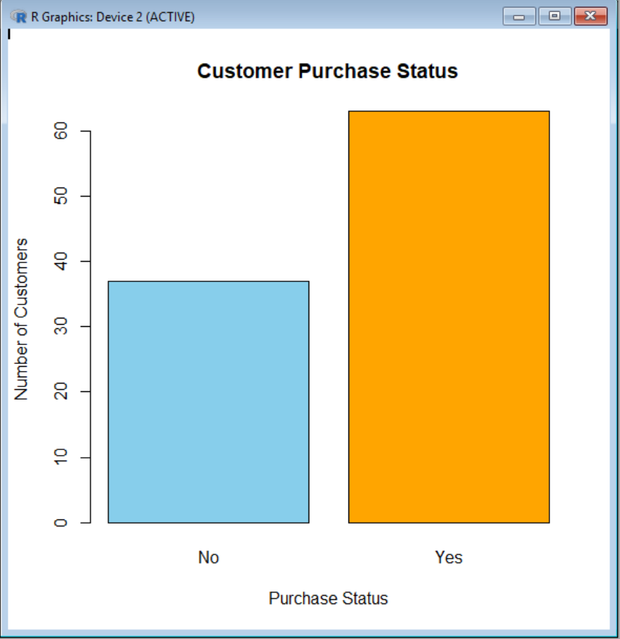
Interpretation: If the p-value is less than 0.05, there is statistically significant evidence that more than 50% of customers make purchases.

2. Customer segmentation — Chi-square test
Question: Is there an association between customer segments and purchase status?
Variables: Two categorical variables — Segment and Purchase.
Mathematical formula:
$$χ^{2}=\sum{\frac{{\left(O-E\right)}^{2}}{E}}$$
$$E=\frac{\text{Row Total}×\text{Column Total}}{\text{Grand Total}}$$
Where $O$ is the observed frequency and \(E\) is the expected frequency.
R Code:

2. Chi-Square Test
set.seed(123)
n <- 150
spending <- runif(n, 500, 10000)
frequency <- sample(1:20, n, replace = TRUE)
# Create customer segments
customer_data <- data.frame(spending, frequency)

km <- kmeans(scale(customer_data), centers = 3,
nstart = 20)
customer_data$Segment <- factor(km$cluster,
labels = c("Low", "Medium", "High"))
# Simulate purchase status
customer_data$Purchase <- ifelse(
customer_data$spending > 6000, "Yes", "No"
)
# Contingency table and chi-square test
tab <- table(customer_data$Segment,
customer_data$Purchase)
print(tab)
result <- chisq.test(tab)
print(result)
# Grouped bar chart
barplot(t(tab), beside = TRUE,
col = c("skyblue", "orange"),
main = "Purchase Status by Customer Segment",
xlab = "Customer Segment",
ylab = "Number of Customers",
legend.text = TRUE)
OUTPUT: Bar chart
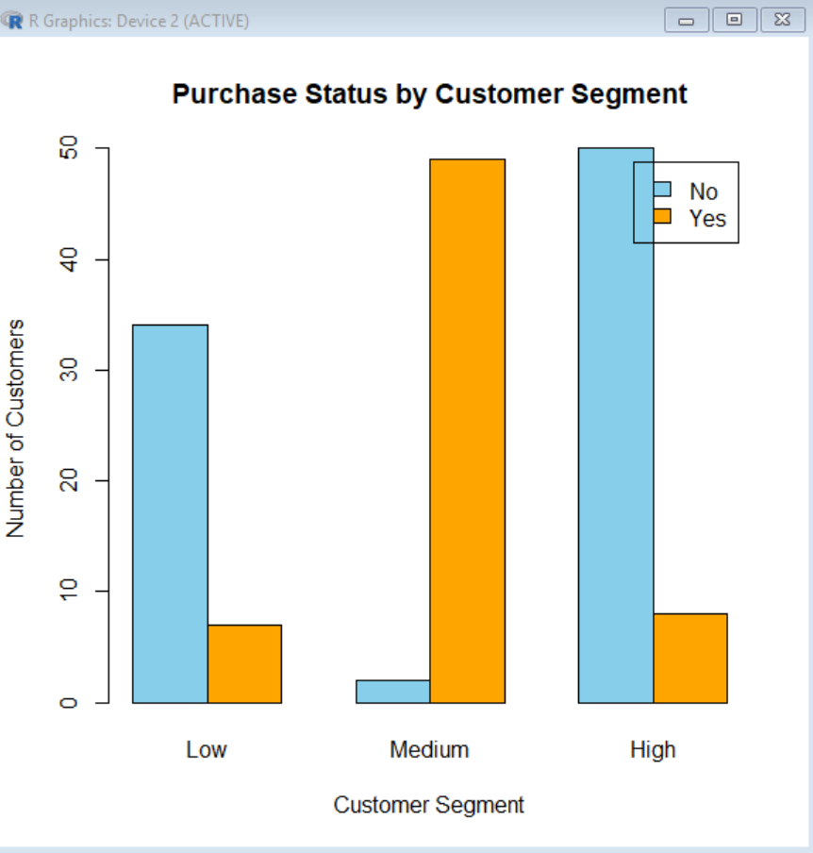
Interpretation: A p-value below 0.05 suggests an association between customer segment and purchase status. The simulated purchase labels are illustrative, not real customer findings.

3. Customer spending — One-sample t-test
Question: Is the average customer spending significantly different from ₹5,000?
Variable: One numerical variable — Spending.
Mathematical formula:
$$t=\frac{\overline{x}-μ_{0}}{s/\sqrt{n}}$$
Where $\overline{x}$ is the sample mean, $μ_{0}=5000$, $s$ is the sample standard deviation, and $n$is the sample size.
R code:
3. One-Sample T-Test

set.seed(123)
spending <- round(rnorm(50, mean = 5500, sd = 1200))
# Test average spending against Rs. 5000
result <- t.test(spending, mu = 5000)
print(result)
# Histogram
hist(spending,
main = "Distribution of Customer Spending",
xlab = "Spending (Rs.)",
ylab = "Number of Customers",
col = "lightgreen",
border = "white")
abline(v = mean(spending), col = "red", lwd = 2)
abline(v = 5000, col = "blue", lwd = 2, lty = 2)
legend("topright",
legend = c("Sample Mean", "Benchmark: Rs. 5000"),
col = c("red", "blue"),
lty = c(1, 2), lwd = 2)

OUTPUT: Histogram
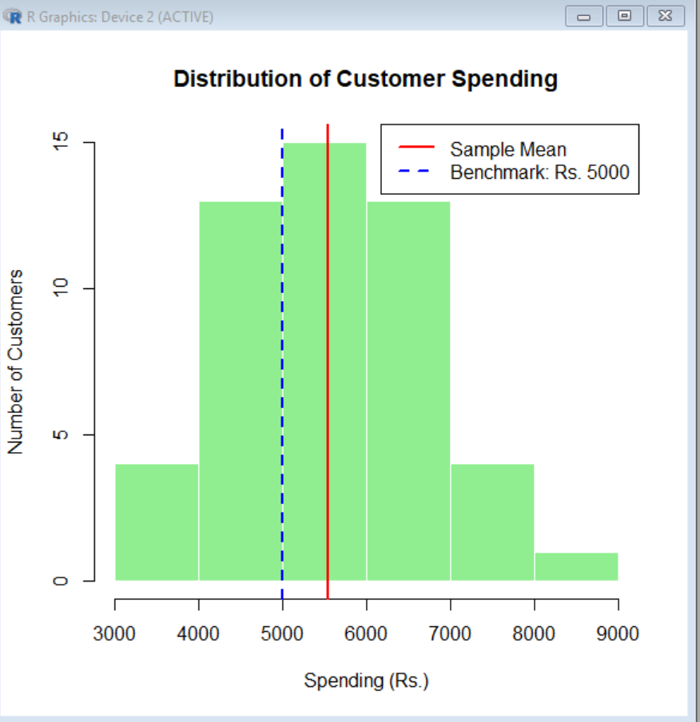

Interpretation: If the p-value is below 0.05, the average spending differs significantly from ₹5,000.

4. Customer behavior — Two-sample t-test
Question: Does average customer spending differ between customers who purchase and those who do not?
Variables: One numerical variable — Spending; one categorical variable — Purchase.
Mathematical formula:
$$t=\frac{{\overline{x}}_{1}-{\overline{x}}_{2}}{\sqrt{\frac{s_{1}^{2}}{n_{1}}+\frac{s_{2}^{2}}{n_{2}}}}$$
Where ${\overline{x}}_{1},{\overline{x}}_{2}$are the group means, $s_{1},s_{2}$ are the group standard deviations, and $n_{1},n_{2}$ are the group sizes. This is the Welch two-sample t-test formula.
R code:

4. Two-Sample T-Test
set.seed(123)
n <- 100
purchase <- sample(c("Yes", "No"), n,
replace = TRUE)
spending <- ifelse(
purchase == "Yes",
rnorm(n, mean = 6000, sd = 1200),
rnorm(n, mean = 4000, sd = 1000)
)
customer_data <- data.frame(purchase, spending)
# Compare spending between groups
result <- t.test(spending ~ purchase,
data = customer_data)
print(result)
# Box plot
boxplot(spending ~ purchase,
data = customer_data,
main = "Spending by Purchase Status",
xlab = "Purchase Status",
ylab = "Spending (Rs.)",
col = c("lightblue", "lightpink"))

OUTPUT: Box plot

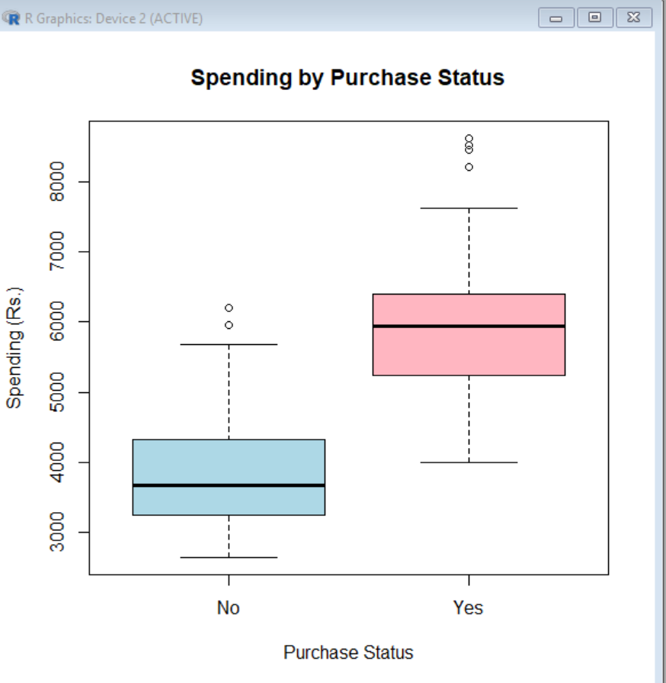
Interpretation: If the p-value is below 0.05, average spending differs significantly between the two purchase groups.

5. Customer buying trends — Correlation test
Question: Is customer spending related to purchase frequency?
Variables: Two numerical variables — Spending and Purchase_Frequency.
Mathematical formula:
$$r=\frac{\sum{\left(x_{i}-\overline{x}\right)}\left(y_{i}-\overline{y}\right)}{\sqrt{\sum{{\left(x_{i}-\overline{x}\right)}^{2}}\sum{{\left(y_{i}-\overline{y}\right)}^{2}}}}$$
Where $r$ is Pearson's correlation coefficient, ranging from -1 to +1.
R code:

5. Correlation Test
set.seed(123)
n <- 100
purchase_frequency <- sample(1:20, n, replace = TRUE)
spending <- 1000 + 400 * purchase_frequency +
rnorm(n, mean = 0, sd = 1500)
# Correlation test
result <- cor.test(spending, purchase_frequency,
method = "pearson")
print(result)
# Scatter plot
plot(purchase_frequency, spending,
main = "Spending vs Purchase Frequency",
xlab = "Purchase Frequency",
ylab = "Spending (Rs.)",
pch = 19,
col = "darkgreen")
abline(lm(spending ~ purchase_frequency),
col = "red", lwd = 2)

OUTPUT: Scatter plot

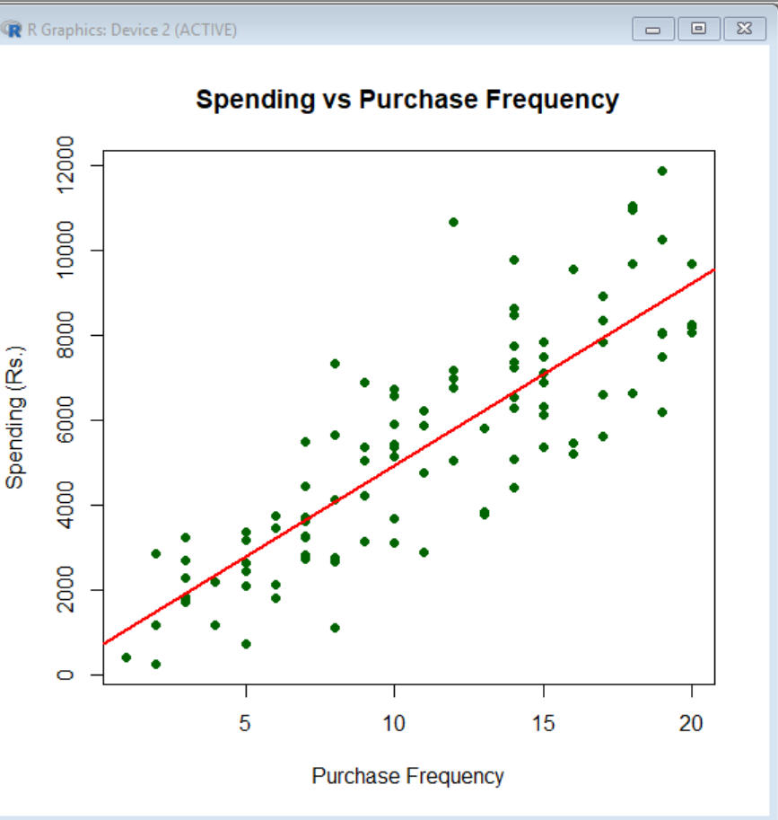
Interpretation: A positive correlation indicates that higher purchase frequency tends to be associated with higher spending. A p-value below 0.05 indicates statistically significant evidence of a linear relationship.

